Unit 3 Weather
Step one: Warm –up
Act out “Let’s talk”
Step two: Presentation
1、Teach the words “socks、shoes、pants” by asking “Where are my socks?” ”What colour ?” “White” Notice the usage of the verb “are”

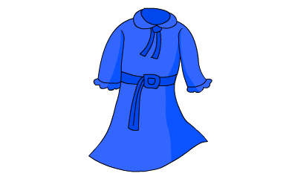
一、看图，完成句子。
1．A：What is the ?
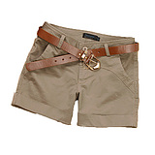
B: It’s .(白色的)
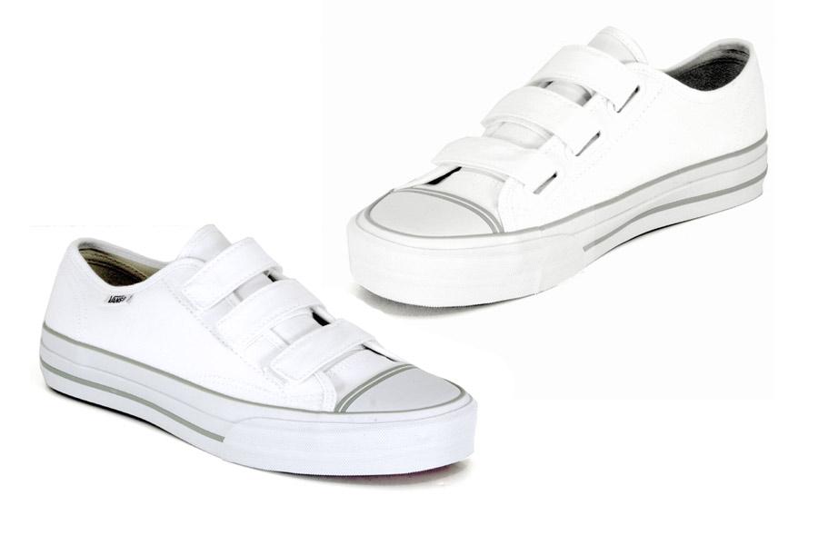
2. A： are my and ?
B: On the bed.
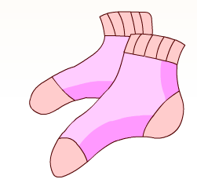
3. A：What are they? Are they ?
B: Yes.
4. A： my new skirt?
B: your new skirt?
A: Yes, it is . Thank you.
5. A: Is this your ?
B: No, .
A: What is ?
B: It’s white.

二、回答问题.
1、What colour is your T-shirt? （蓝色）
.
2、What colour is the jacket? （红色）
.
3、What time is it? (7:00)
.
4、Is that your sweater ? (Mike’s)
.
5、Whose is this shirt? (Amy’s)
.

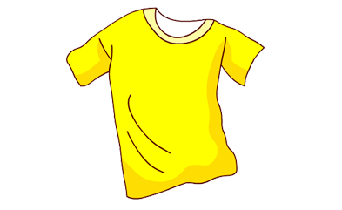
三、完成句子。
1．
It’s yellow.
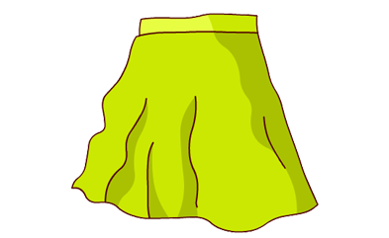
2.
Yes, it’s my skirt.
3.
My shirt is red.

